**DAILY ONLINE ACTIVITIES SUMMARY**

|  |  |  |  |  |  |  |  |  |
| --- | --- | --- | --- | --- | --- | --- | --- | --- |
| **Date:** | **10-July-2020** | | | | | **Name:** | **RACHANA K N** | |
| **Sem & Sec** | **6th Sem B** | | | | | **USN:** | **4AL17CS070** | |
| **Pre-placement Training Summary** | | | | | | | | |
| **Subject** | |  | | | | | | |
| **Max. Marks** | | **-** | | **Score** | | | **-** | |
| **Online Certification Summary** | | | | | | | | |
| **Course** | Python Data Structures | | | | | | | |
| **Certificate Provider** | | | **Coursera** | | **Duration** | | | **1 week** |
| **Coding Challenges** | | | | | | | | |
| 1. **Problem Statement:1. Python Program for Efficient program to print all prime factors of a given number.** | | | | | | | | |
| **Status:Completed** | | | | | | | | |
| **Uploaded the report in Github** | | | | | **Yes** | | | |
| **If yes Repository name** | | | | | **DAILY_STATUS** | | | |
| **Uploaded the report in slack** | | | | | **Yes** | | | |

Online Certification Details:

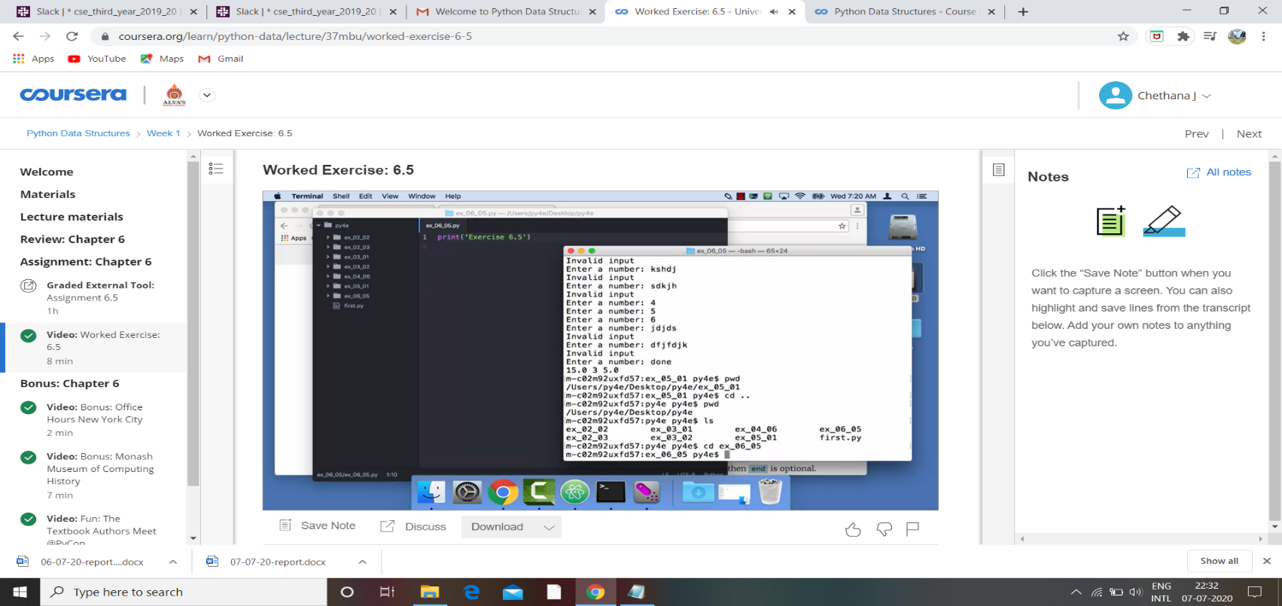

Coding Challenges Details:

1. **Python Program for Efficient program to print all prime factors of a given number.**

**n=int(input("Enter an integer:"))**

**print("Factors are:")**

**i=1**

**while(i<=n):**

**k=0**

**if(n%i==0):**

**j=1**

**while(j<=i):**

**if(i%j==0):**

**k=k+1**

**j=j+1**

**if(k==2):**

**print(i)**

**i=i+1**

**OUTPUT**

